Landholder information for the safe use and management of strychnine for wild dog traps



Copies of this publication can be obtained from the DAFWA website (<https://agric.wa.gov.au>) or by contacting your local biosecurity officer at the Department of Agriculture and Food, Western Australia (DAFWA). To find your nearest DAFWA office, contact:

Department of Agriculture and Food, Western Australia

Physical Address: 3 Baron-Hay Court, South Perth, Western Australia 6151, Australia.

Postal Address: Locked Bag 4, Bentley Delivery Centre WA 6983.

Phone: +61 (0)8 9368 3333 Fax: +61 (0)8 9367 7389 [DAFWA website](http://www.agric.wa.gov.au/): <https://agric.wa.gov.au>.

Authors: DAFWA: Regulatory Standards and Invasive Species

Copyright © Western Australian Agriculture Authority, 2015.

Except where the Copyright Act otherwise allows, this publication may not be reproduced in whole or in part without the prior permission of the copyright holder. Application for permission should be addressed to the Director, Information and Knowledge Management, Department of Agriculture and Food, Western Australia, Locked Bag 4, Bentley Delivery Centre WA 6983.

**IMPORTANT DISCLAIMER**

The Chief Executive Officer of the Department of Agriculture and Food and the State of Western Australia and their employees and agents (collectively and individually referred to below as DAFWA) accept no liability whatsoever, by reason of negligence or otherwise, arising from any use or release of information in, or referred to in, this publication, or any error, inaccuracy or omission in the information.

Although reasonable care is taken to make the information accurate at the time of publication, DAFWA does not make any representations or warranties about its accuracy, reliability, currency, completeness or suitability for any particular purpose. Before using the information, you should carefully evaluate its accuracy, currency, completeness and relevance for your purposes.

The information is not tailored to the circumstances of individual farms or businesses, and does not constitute legal, business, scientific, agricultural or farm management advice. We recommend before making any significant farming, business or wild dog control decisions, you obtain such advice from appropriate professionals who have taken into account your individual circumstances and objectives.

The legislation (Acts, Regulations, Notice) and the Code of Practice referred to in this information regulate the use of strychnine in Western Australia. While the information refers to or summarises parts of the legislation and Code of Practice, it does not modify or replace these. The legislation is described at pages 10 and 11 of the Code of Practice, but it, and the Code of Practice, should be read in full for their complete, accurate content and effect.

**Table of contents**

Introduction 4

Strychnine is regulated under legislation 5

Properties of strychnine 6

Mode of action of strychnine 6

Biodegradation of strychnine 7

Sensitivity of animals to strychnine 7

Personal safety 9

First aid 10

11 Steps to using strychnine on wild dog traps 12

Important points to remember 25

Appendix A: Identifying wild dog and fox tracks 26

Appendix B: Optional self-assessment questions 27

Appendix C: Template notification letters for intention to use strychnine. 28

# Introduction

Strychnine is a highly poisonous substance that is used in Western Australia (WA) for the control of wild dogs and emus. Its use is restricted by law.

This manual in conjunction with the strychnine code of practice and associated legislation outlines your roles and responsibilities for using and managing strychnine for wild dog control. In particular, this manual outlines the information you need to know in regard to:

* the legislative requirements for strychnine control in WA
* the properties and mode of action of strychnine
* how to lodge an application to use strychnine
* how to safely store and transport strychnine
* the procedures and notification required to carry out a control program using strychnine
* how to identify signs of poisoning and effect appropriate first aid treatment
* your responsibilities for notifying the Department of Agriculture and Food, Western Australia (DAFWA) and the Police of any accidents or incidents
* methods for evaluating the success of a trapping program.

Before you may be given approval to use strychnine, you must demonstrate to your biosecurity officer that you understand how to use and manage strychnine safely.

You can demonstrate your knowledge by completing a short, open-book assessment provided by your biosecurity officer or online training via Moodle. The assessment questions will be based on the information contained in this manual.

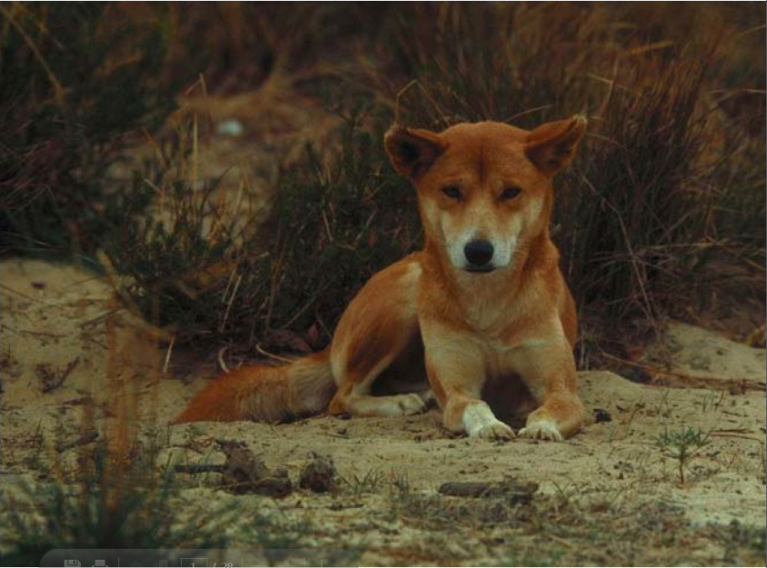

Figure 1 A wild dog

Once your biosecurity officer is satisfied that you know how to use and manage strychnine safely, your ‘restricted chemical product risk assessment permit application form’ can be processed and, subject to a complete risk assessment, approved.

# Strychnine is regulated under legislation

Law restricts the use of strychnine. Misuse of strychnine endangers you, your family, your pets, the public, farm animals and wildlife and may impact on the future availability of this poison as a pest control method.

Strychnine use in Australia is closely regulated by Commonwealth and State government agencies. The *Poisons Act 1964* and associated Poisons Regulations 1965 are the primary legislation that covers the manufacture, sale, use and possession of strychnine in WA.

The Poisons (Section 24) (Registered Pesticide Strychnine Alkaloid) Notice 2010 restricts strychnine as a Schedule 7 poison and is therefore only available from retailers licensed to sell Schedule 7 poison products.

The Code of Practice on the ‘Safe use and management of strychnine’ provides the intent of the legislation and elaborates on the procedures for training and handling of strychnine products. A full copy of the code should be supplied with this manual. If not, please ask your biosecurity officer for a copy.

## Legislation for wild dog control

Under the *Animal Welfare Act 2002* and associated Animal Welfare (General) Regulations 2003, it is mandatory to use strychnine on jawed traps used for wild dog control in WA. This is done to ensure a rapid death and reduce the long-term suffering of a trapped dog. When a dog is captured it will bite down on the poisoned jaws of the trap, attempting to free its leg and in doing so it will ingest the poison.

Schedule 1 of the Poisons (Section 24) (Registered Pesticide Strychnine Alkaloid) Notice 2004 lists the local government districts where wild dog traps are allowed to be used. It is an offence to use traps outside of these areas unless special approval is granted. This list can also be found at the back of the Code of Practice.

Strychnine registration and restrictions:

In WA, strychnine is only registered for the control of:

a) wild dogs – strychnine is applied to the jaws of wild dog traps

b) emus – strychnine is mixed with grain to make emu bait.

It is an offence to use strychnine for any purpose contrary to the directions for use supplied with the product.

It is an offence to use strychnine without the approval of the Chief Executive Officer (or delegated officer) DAFWA.

# Properties of strychnine

Strychnine is an alkaloid – a class of organic compounds that contain nitrogen, isolated from plants. Strychnine crystals are derived from the dried ripe seeds of a small tree native to India – *Strychnos nux-vomica*. Species are also found in northern Australia, Vietnam and Sri Lanka. Historic records indicate that the ‘Strychnine Alkaloid’ has been used to kill dogs, cats and birds in Europe as far back as 1640.

## Properties of strychnine include

* white crystalline substance (sometimes dyed pink)
* characteristic bitter taste
* slight odour
* almost entirely insoluble in water – very stable unless in acid soils where salt formation can render substance soluble in water and allow leaching
* non-flammable. May evolve toxic gases (carbon/nitrogen oxides and hydrocarbons) when heated to decomposition.

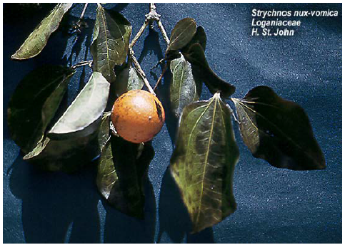

Figure 2 Strychnine leaves and fruit

# Mode of action of strychnine

Strychnine is highly toxic and can be rapidly absorbed through the mucous membranes of the mouth, stomach and small intestines. There are three main ways that strychnine can enter the body:

1. inhalation
2. ingestion
3. broken skin.

Once absorbed, strychnine enters the blood stream and acts on the central nervous system, affecting the transmission of nerve impulses which control muscle contraction. Fortunately, the kidney and liver work to eliminate the poison from the body and if a sub-lethal dose is taken, this inhibition is reversible.

Strychnine also causes an increase in the levels of glutamic acid in the brain. This can lead to the skeletal muscles becoming hyper excitable causing simultaneous muscle contraction, convulsions and seizures which prevent respiration. Death generally results from suffocation or exhaustion.

# Biodegradation of strychnine

## Secondary poisoning

Secondary poisoning can occur when an animal feeds on poisoned carcasses. Although strychnine is not assimilated into soft tissues or bone, strychnine remaining in the gut of a poisoned carcass is potentially hazardous to other carnivores.

Appropriate measures should be taken to reduce the risk of secondary poisoning.

## Persistence in the environment

Strychnine shows little or no breakdown by exposure to light.

## Degradation

Strychnine can be degraded in some soils as a result of microbial activity. However, this degradation is generally very slow. Microbial degradation doesn’t appear to occur in some instances because the strychnine gets bound to soil particles, a factor that is influenced by the soil pH.

## Water catchments

Strychnine is poorly soluble in water. Contamination of drains and waterways must be prevented.

# Sensitivity of animals to strychnine

The table below shows the relative toxicity of strychnine to various species. The mean lethal dose (LD50mg/kg) is the amount of strychnine (measured in milligrams of strychnine per kilogram of target animal body weight) found to be fatal to 50% of the exposed animals. Note that, unlike 1080, the range of strychnine-sensitivity is fairly narrow and therefore it is more difficult to achieve target specificity. It is for this reason that the use of strychnine in WA is significantly restricted.

Just how toxic is strychnine?

The amount of strychnine that is likely to kill 50% of 80kg adults is 80mg (80kg x 1mg/kg)

The amount of strychnine applied to one dog trap is between 250 and 500mg (about half a teaspoon).

500mg has the potential to kill six adults!

A complete commitment to safety is essential!

Table 1 The relative toxicity of strychnine to various species

| Species | Mean LD50 mg/kg |
| --- | --- |
| Human | 1.0 |
| Dog | 1.0–1.2 |
| Cat | 0.7 |
| Rabbit | 0.6 |
| Sheep | 7.5 |
| Cattle | 15.0 |
| Pig | 0.5–1.0 |
| Rat (Norway) | 6.0–8.0 |
| Bungarra (*Varanus gouldii* ) | 8.0 |
| Bobtail lizard | 12.0 |

# Personal safety

## Essential personal protective equipment

* chemically impervious gloves
* impervious protective clothing (overalls, boots etc.)
* chemical splash goggles
* dust mask appropriate to inhalation risk, for example, class P1 particulate respirator or full face class P3 particulate respirator in high dust levels.

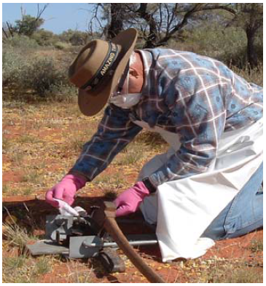

Figure 3 Personal protective equipment must be worn while using strychnine

Appropriate breathing apparatus must be worn!

Strychnine crystals are generally supplied as a very fine powder which can easily become airborne causing a serious risk of poisoning through inhalation.

## Additional precautions

* Ensure area is clear of all unprotected personnel.
* Wear appropriate breathing apparatus and open containers downwind, away from body.
* Do not eat, drink or smoke whilst using strychnine.
* Ensure that soap and water are available whenever strychnine is being used.
* Wash down any spills on equipment or people immediately.
* After use, wash all equipment and surfaces thoroughly with water and detergent or solvent. Dispose of rinsate and used product containers as outlined in the directions for use.
* Remove and wash protective clothing and wash hands thoroughly.
* In the case of burning poisoned carcasses, unused strychnine crystals and/or used containers, toxic gases may develop when strychnine is heated to decomposition. Ensure that the incineration is controlled, remain upwind, and wear full protective equipment including self-contained breathing apparatus.
* See ‘Safety Data Sheet’ for further information.

# First aid

Recognising the signs of poisoning early and acting quickly to apply first aid can increase the chances of surviving strychnine poisoning.

## Symptoms of strychnine poisoning

### Chronic poisoning signs (long-term, low-level exposure)

* muscle rigidity
* joint stiffness
* muscle aches
* weakness
* headache
* light sensitivity.

A low level of tolerance appears to develop, however repeated higher doses can lead to convulsions and other acute signs. Continual chronic doses can ultimately cause severe incapacitation.

### Acute poisoning signs (single large dose)

15 to 30 minutes after ingestion the following symptoms may be displayed:

* initial violent convulsion
* restlessness/apprehension
* heightened perception (hearing etc.)
* abrupt movements
* exaggerated reflexes
* muscular stiffness of face and legs
* body arched, fists clenched, jaw clamped
* face in fixed grin and eyes bulging
* breathing stops and patient turns blue
* cold sweat
* pupils may contract.

Between convulsions the muscles relax completely but hypersensitivity and convulsions may return every 10 to 15 minutes. One to ten attacks may be experienced before recovery or death.

### First aid for strychnine poisoning



If poisoning occurs immediately call 000 to request an ambulance!

Call 13 11 26 for Poisons Information.

a) Remove any contaminated clothing from the patient.

b) Wash any affected skin thoroughly through free flowing clean water.

c) Do not induce vomiting (risk of choking).

d) Do not administer anything by mouth (risk of choking).

e) Place the patient into the recovery position to maintain their airway.

f) If the patient stops breathing only administer resuscitation if you can ensure that there is no risk to the rescuer of ingesting the poison from the patient, (e.g. through mouth to mouth contact). A suitable barrier mask should be used if applying resuscitation. Be aware that the patient may have convulsions.

g) Reassure the patient and keep them calm. If possible keep the patient in a quiet, dark place (as they may be highly sensitive to noise and light).

h) Wait for medical staff to arrive or if this is not possible take patient to doctor/hospital as soon as possible.

Make sure the Strychnine product container, product ‘Directions for use’, and Safety Data Sheet (SDS) are available to medical staff.

# 11 Steps to using strychnine on wild dog traps

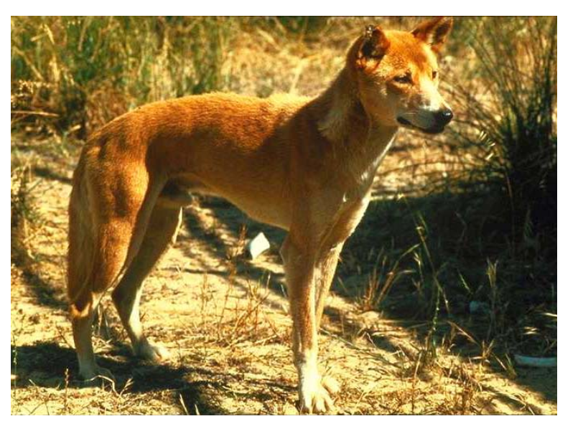

## Step 1: Discuss control options with biosecurity officer

Before making an application to use strychnine, you should ask yourself these questions:

1. Is it necessary to use traps to control the wild dogs?
2. Am I confident that public safety and the risk to non-target species can be managed?
3. Is there an effective alternative control method that could be used?
4. Can I implement a combination of methods to achieve a greater level of control?

Often, a carefully planned, integrated approach is most effective. Your biosecurity officer can help you to develop an effective control strategy using one or more of these methods:

* 1080 ground baiting
* 1080 aerial baiting (for areas that are inaccessible by ground)
* exclusion fencing
* traps poisoned with strychnine
* shooting
* using guard animals (for example, llamas, maremma dogs).

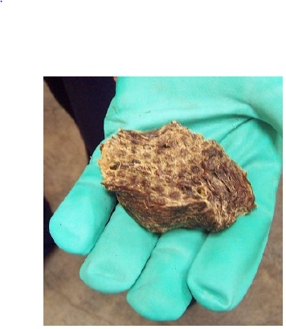

Figure 4 A meat bait

Integrated approach and community effort:

Multiple numbers of wild dogs can often initially be reduced using 1080 baits, leaving fewer animals to control using labour intensive trapping.

Your biosecurity officer can help you to organise neighbouring properties to undertake control programs at the same time. This combined effort can often achieve a significant reduction in the target species giving a longer-term effect.

## Step 2: Demonstrate a thorough knowledge of using and managing strychnine products

In accordance with the Code of Practice, a person must demonstrate a thorough knowledge and understanding of using and managing strychnine safely before a restricted chemical permit application can be approved.

You can demonstrate your knowledge to your DAFWA biosecurity officer by completing a 20–question open-book assessment. All of the answers to the assessment can be found in this manual. You may like to test your own knowledge before-hand by attempting the self-assessment found in Appendix 2 of this manual.

## Step 3: Submit a restricted chemical product risk assessment permit application form and map for the intended control program

A ‘restricted chemical product risk assessment permit application form’ and map must be completed for every intended new strychnine control program. The restricted chemical product risk assessment permit application form can be found on the DAFWA website (https://agric.wa.gov.au/n/2482).

The information that you will be required to provide on the permit application form includes:

* Target species and quantity of strychnine required.
* Details of the S7 retailer who will supply the strychnine.
* The name of the person picking up and transporting the strychnine from the retail outlet and the person nominated to lay the poison. All must demonstrate a thorough knowledge of using and managing strychnine safely.
* Proposed start and end date of intended control program.

Restrictions to remember!

The use of wild dog traps is restricted to the pastoral areas and prescribed agricultural areas listed in the Code of Practice on the safe use and management of strychnine. It is an offence to use traps outside of these areas unless special authority is granted.

### A checklist for producing a map of your proposed strychnine program

You must submit a map of your proposed strychnine control program with your restricted chemical product permit application form. Any of the following formats will be acceptable:

* hand drawn map
* computer digitised map
* aerial photograph (with labelled features).

Your map must clearly show the following features:

**Proposed exclusion zones:** all areas where traps are not to be used, including areas posing a potential risk to human and non-target species trapping/poisoning must be clearly identified as exclusion zones (for example, around buildings, recreational areas, bush remnants, water courses etc.). Always refer to product ‘Directions of use’ for restrictions. It is also sound management practice to identify on your map the general area where traps are likely to be laid.

**Roads and tracks:** Include the tracks used to access sites where strychnine is to be used.

**Location of dwellings:** Mark the location of dwellings on your property and those on adjacent properties.

**Constructed recreational sites.**

**Water bodies and water courses.**

**Proposed location of warning signs:** Mark on your map where you propose to place your warning signs. They must be erected at entrances and other strategic points.

**Property access points and boundaries:** Include those used for public use and management use.

**Disposal site** Indicate the location where used strychnine containers and excess strychnine poison are to be burnt and buried.

**Significant areas of bush/scrub.**

**Map scale:** Include a map scale or estimate the distance between the traps and bush areas, dwellings, recreational areas, water bodies etc.

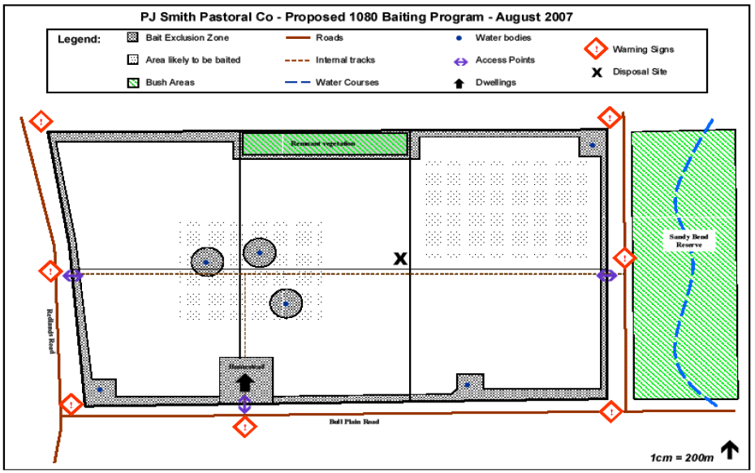

Figure 5 Example of a map to submit with your proposed use of strychnine

### Risk assessment

## Once your application form is submitted, the biosecurity officer will conduct a risk assessment to determine if it is safe (a manageable risk) to use strychnine in the proposed areas.

There are three risk categories associated with the risk assessment:

* minimal risk: where strychnine can be used in accordance with the directions for use with no additional precautions
* moderate risk: where some potential risk may occur but this can be overcome with additional precautions
* extreme risk: where approval to use strychnine is likely to pose an unacceptable risk which cannot be adequately managed with additional precautions.

### Approval documentation

## If the supply of strychnine is approved, then the authorising DAFWA officer will issue you with a restricted chemical product permit and a copy will be sent to your nominated S7 retailer. This permit contains the following important information:

* period of time within which the poison must be used
* details of the quantity of strychnine approved
* any additional conditions that may be required to manage the risks associated with the use of strychnine.

Strychnine can only be laid on the land described on the restricted chemical product permit.

### When use of strychnine will not be approved

Approval for use of strychnine will not be given where a risk assessment has established that the proposed use of strychnine-treated grain poses an unacceptably high risk.

Where strychnine cannot be used because of unacceptable risks, alternative control measures may be suggested.

## Step 4: Have the nominated ‘Receiver’ take the restricted chemical product permit to an S7 retailer to purchase strychnine

The restricted chemical product permit will nominate the person that is to pick up the strychnine from the S7 retailer. The retailer has a copy of the permit from DAFWA. This person must provide identification to the retailer.

It is an offence for someone other than the person nominated on the restricted chemical product permit to purchase or pick up strychnine from the S7 retailer.

## Step 5: Transport and store strychnine in accordance with the code of practice

### Transport

* Strychnine products must be transported in a locked container in a secured part of the vehicle.
* Strychnine must never be transported with foodstuffs.
* Vehicles carrying poison should not be left unattended.
* Domestic animals should be segregated from the poison.
* Strychnine should be segregated from any passengers and the driver of the vehicle.

Carrying strychnine in a small locked toolbox inside an anchored and locked tool-chest of a utility would be ideal transportation method.

### Storage

Strychnine products must be always stored in their original packaging in a double locked container except when they are required for immediate use. Strychnine products must always be kept in areas inaccessible to the public and must not be stored with foodstuffs.

The following types of storage can be used:

* designated, marked poison cupboard
* chained and padlocked in a locked security store
* locked cupboard
* approved firearm safe.

All storage areas must comply with the dangerous goods regulations for storage safety, security and warning signs. Safety Data Sheets (SDS) are also required to be kept with all poisons stored.

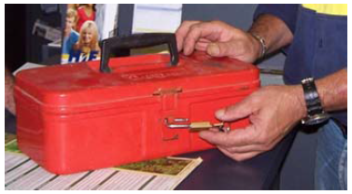

Figure 6 Strychnine must be transported in a locked container.

It is an offence to store strychnine outside of the approved control period. Once the period of your control program has expired you must destroy all remaining strychnine and product containers. This includes destroying the strychnine padding that has already been applied to the jaws of any wild dog traps.

### Storage of wild dog traps

If the control period is still current you may store wild dog traps with strychnine pads intact. The strychnine pad should be sealed off with insulation tape and the traps should be stored ensuring the same precautions are taken as for the storage of strychnine crystals.

Traps with strychnine wrapping can only be stored during the approved control period. Once the program is completed, the strychnine wrapping must be removed and destroyed by burning and burying the ash.

## Step 6: Give all neighbours at least 72 hours’ notice in writing and erect warning signs prior to setting traps

### Notify your neighbours

It is an offence to use strychnine without giving neighbouring landholders at least 72 hours (but not more than 14 days) notice. This notice must be given in writing and must inform the recipient of the following:

* The period that strychnine will be used on the property.
* Address of property where traps are to be laid.
* Target species.

Information on the hazards associated with strychnine (that is, potential risks to humans, livestock and domestic animals).

We recommend the use of the template letter at the back of this manual to notify your neighbours of your intention to use strychnine (Appendix 3).

### Erect warning signs

Prominent warning signs that alert the public that strychnine is being used on the property, must be displayed during the period of the control program and for at least one month afterwards.

The warning signs must be erected at property entrances and other strategic points, (for example, in the vicinity of the traps) as per the ‘Directions for use’.

A warning sign indicating 1080 and strychnine are being used in the area

Figure 7 Prominent warning signs must be displayed when using strychnine

## Step 7: Restrain pets and working dogs and exclude unauthorised persons

At all times you must ensure that any un-authorised people (for example, children) are not able to gain access to the poison or traps. Ensure that pets and working dogs are restrained during the trapping period.

## Step 8: Have the nominated ‘layer’ prepare and lay traps

You must be authorised to use Strychnine. Unauthorised possession is an offence.

The ‘Directions for use’ supplied with your strychnine product and restricted chemical product permit will clearly outline the restrictions and conditions for your control program.

The directions for use supplied with the strychnine product will include information on:

* the appropriate personal protective equipment that must be worn
* the amount of strychnine to apply
* methods of applying strychnine to the trap
* trap placement and location restrictions
* disposal of carcasses, un-used products, used containers.

It is an offence for anyone to use strychnine products contrary to instructions given on the ‘Directions for use’ and the restricted chemical product permit unless authorised in writing by the Director General or delegated officer.

Trapping is labour intensive and expensive making it unsuitable for general population reduction. However, trapping can be very effective in dealing with individual wild dogs creating problems and is usually used where 1080 baiting has been ineffective.

Both rubber-padded and unpadded steel-jawed traps can be used for wild dog control in WA. It is mandatory that the jaws of these traps be poisoned with strychnine.

Humane, successful use of traps requires training and experience. Incorrect setting and placement can result in individual wild dogs becoming trap-shy. Careful selection of trap sites and the use of lures also reduce the chances of catching non-target animals.

### Check that traps are in good working condition

Traps must be tested and (if necessary) adjusted prior to each setting. Check all parts including:

* Springs: Should be sufficiently strong and moving freely.
* Eye of spring: Ensure that the eye of each spring moves freely over the support post which holds the lug-ends of the jaws.
* Jaws: Make sure the jaws meet and mesh together squarely and that they pivot freely without being too loose.
* Lug-end of jaw: Check that the lugs are secure and are soundly through the socket holes in the support posts.
* Plate: Ensure that the plate moves freely with minimal side play. When the plate is down and the tongue is pushed towards the plate they should be good clearance (1–2mm) between the end of the tongue and the catch on the plate. Never be tempted to enlarge the plate area of any trap.
* Tongue: Ensure the curved hinge of the tongue is well rounded, without flat spots. Ensure the tongue rotates freely around its hinge point.
* Catch: Ensure the notch in the catch where the tongue engages the plate is kept filed at right angles.
* Chain and swivel: Check the links and connection to the trap.
* Weight: Use a flat piece of iron or other item weighing several kilograms. Connect the weight to the chain with heavy gauge, soft wire.

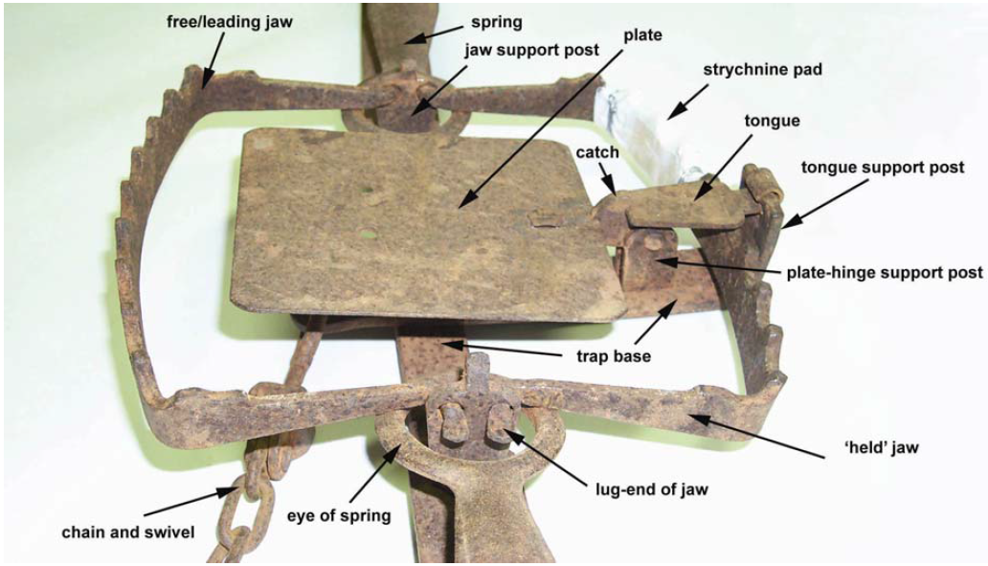

Figure 8 Close up of the plate/jaw area of a lanes trap, showing the major parts including the strychnine pad

## Identifying signs of wild dogs

* Check for prints and scats early in the day along vehicle tracks, old roads, fence lines, animal pads and livestock tracks. The size of prints can vary greatly depending on sex, age and gender of the dog as well as speed and ground conditions. Forefeet are always larger than hind-feet.
* Don’t confuse fox prints with dog prints. See diagram at the back of this manual for more information (Appendix 1).
* Dog scats often contain bone fragments and substantial quantities of hair. Aggregations of dog scats can often be found at features such as creek crossings. Multiple scats of various ages can indicate that one or more dogs have been visiting the area for some time and that they may reside in the area.
* Urine of wild dogs is harder to detect – look for visual signs such as scratches made on the ground.
* Listen for howling just after sun-set and just before sun-rise.
* Look for unusual behaviour of livestock (for example, flighty sheep and mis-mothered lambs).
* Scavenging birds may lead you to a wild dog or carcasses killed by wild dogs.
* Refer to the ‘Wild dog management best practice manual’ for more information.

## Choosing a suitable trap site

Once you are sure that the trap is in good working condition and the strychnine pad has been prepared, you should select a suitable trap site. Look for an area which shows signs of repeat visits from a dog (for example, multiple tracks of various ages). Find a site where the trap can be set with minimal disturbance to the natural setting.

Consider setting the trap about 1m off the track to avoid injury to non-target species such as wandering stock.

A lure such as dog scats mixed with water is used to attract the dog to the site. When placing the trap and lure, consider the likely direction of the wind to give a greater chance of the dog smelling the lure as it approaches the area.

Position the trap using existing bushes, logs etc. so that the dog can only approach the decoy/lure from one direction – over your trap.

To minimise the chance of leaving human scent near the trap, use a bag or mat as a barrier between yourself and the ground whilst setting the trap. Any excess soil can also be placed on the bag to minimise disturbance to the site whilst digging a hole to embed the trap.

A properly set trap should be undetectable in the natural setting. Incorrect or sloppy setting of traps can lead to wild dogs becoming trap-shy making them much more difficult to catch.

Effective trapping requires training and experience. For specific information on how to set your trap and place the lure, please ask your biosecurity officer or refer to the ‘Wild dog management best practice manual’ available from DAFWA.

## Applying strychnine to your trap

* Prepare the trap so that you have easy access to the held jaw of the trap. It will be this jaw that is wrapped in the cloth. (If both jaws are wrapped they may have insufficient grip to hold an animal’s leg.)
* Cut some hessian or similar coarse fabric into strips. Wrap the cloth strips in a bandaging pattern around one section of the held jaw. Overlap the cloth by 50% as you wrap it around the jaw. Make two full wraps of the jaw.
* Place between 0.25–-0.5g of strychnine crystals (about half a teaspoon) on the flat outside of the jaw, along the wrap you have placed.
* Continue wrapping the jaw with the remaining length of cloth strip making sure the area treated with strychnine is well-covered.
* Use a piece of soft wire to fasten the cloth pad at one end. Start at one side of the cloth pad and firmly wrap the wire several times around the jaw and pad. Twitch this off firmly underneath the jaw, and cut off excess wire. Repeat for the other end of the cloth pad, ensuring that the main central part of the cloth pad is free of wire.
* Set and place the trap as required.

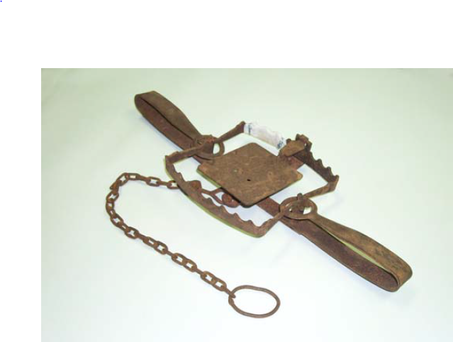

Figure 9 A properly adjusted lanes trap ready to be attached to an anchor point or drag, and set in the ground

Hint: Care must be taken to ensure the wire is not ripped away before the dog chews on the soft wrapping, otherwise the wrapping may be torn away easily, and the dog may not ingest any poison. As a precaution against strychnine loss through the cloth, some ‘doggers’ choose to bind the finished strychnine pad with electrical insulation tape.

Hints for reducing potential risks to non-target species:

• Lay traps at least a metre from tracks to minimise the risk of wandering stock and other animals from accidentally stepping on a trap.

• Minimise the potential risk of secondary poisoning of non-target animals by disposing of poisoned carcasses.

• Avoid using lures that could attract non-target animals.

## Step 9: Check and reset traps and dispose of poisoned carcasses throughout the trapping period

Traps should be checked regularly so that any trapped dog can be disposed of and the trap can be reset. It is also important to check the traps to ensure that any non-target species caught can be released with minimum harm.

Keep a count of the number of dogs caught and the amount of strychnine used. You must report this information as well as any non-target species deaths to your biosecurity officer.

## Step 10: Complete the control program

It is an offence to continue to use strychnine outside of the approved period. Unused strychnine must be disposed of at the completion of the program. It is an offence to keep strychnine for future use. It is an offence to sell or give strychnine to any other person.

Ensure the control program is completed by the end date stated on the restricted chemical product permit (supplied by your biosecurity officer). If you do not think you can complete the program by the end date you must speak to your biosecurity officer to arrange an extension.

### Completing a wild dog trapping program:

* Dispose of any poisoned carcasses found as per the directions for use.
* Remove damaged fabric wrapping from the traps. Burn the wrapping and bury ashes at least 0.5m deep and 10m from water course.
* Burn and bury any remaining strychnine and containers as outlined on the directions for use.
* Notify your biosecurity officer that trapping program has been completed. You will need to notify the biosecurity officer of the following:
  + number of dogs destroyed
  + amount of strychnine used
  + amount of strychnine destroyed
  + details of any accidents or incidents including poisoning of non-target species.

## Step 11: Evaluate the success of the trapping program

It is important to ascertain the effectiveness of the trapping program. The evaluation should determine the effect on the target species population (including damage caused by the target species) as well as any effect on non-target species. Methods of evaluation may include:

* number of wild dogs killed
* reduction in damage caused by the wild dogs
* reduction in the numbers of wild dogs seen
* reductions in signs (for example, tracks) of wild dogs.

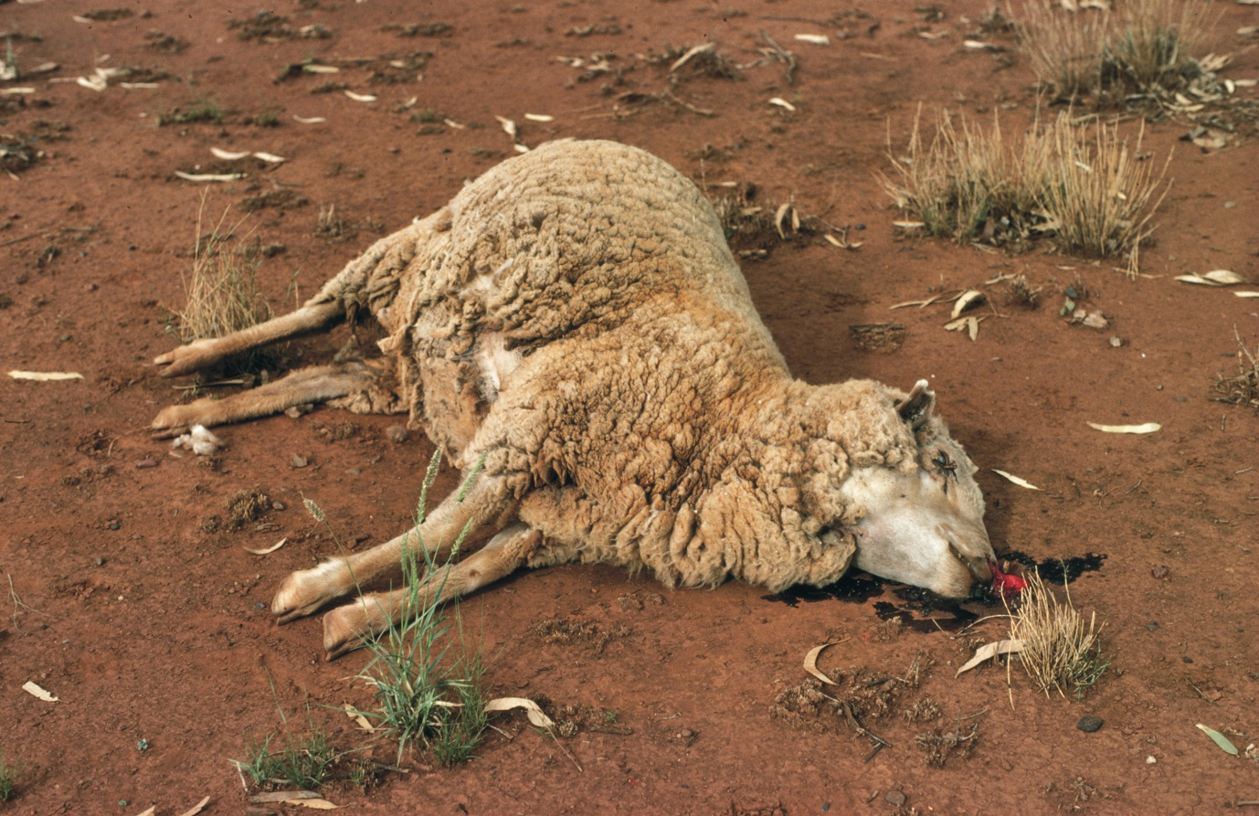

Figure 10 A sheep killed by a wild dog attack

# Important points to remember

Report any strychnine accidents and incidents immediately!

You must report any accidents or incidences to the Department of Agriculture and Food. Where human safety is at risk, the accident/incident must also be reported to the Police. Accidents or incidents include (but are not limited to):

• theft or loss of strychnine products

• human exposure to strychnine and poisoning

• poisoning of non-target species

• spillage of strychnine.

Application contrary to risk assessment conditions set by biosecurity officer.

* Strychnine is highly toxic and a complete commitment to safety is essential!
* Take every precaution to avoid ingesting or inhaling strychnine products.
* Follow all recommended safety procedures for strychnine products.
* Inform your adjacent neighbours in writing prior to using strychnine.
* Adhere to all restrictions and conditions given by the directions for use and DAFWA.
* Do not lay wild dog traps outside of the designated area.
* Choose your sites carefully to avoid trapping non-target species.
* Erect appropriate warning signs and leave in place for one month after trapping.
* Dispose of all un-used strychnine, poisoned carcasses and product containers.
* Do not sell or transfer strychnine to any person.
* Do not store strychnine beyond the approved period of the control program.
* Learn how to apply first aid in case of strychnine poisoning.
* Report any accidents or incidents involving strychnine immediately.

# Appendix 1: Identifying wild dog and fox tracks

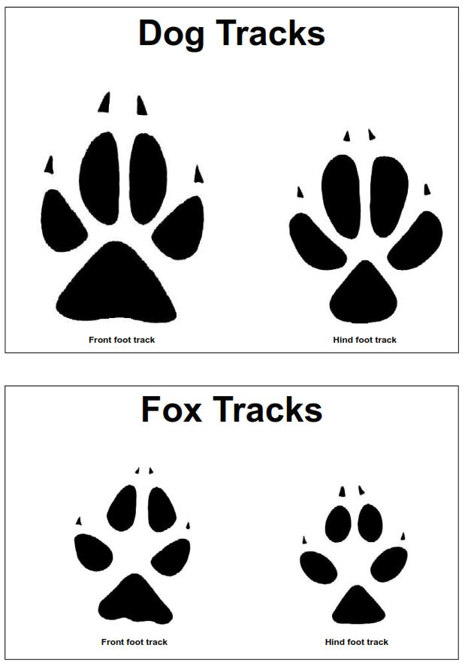

Figure 11 Foot tracks formed by dogs (top image) and foxes (bottom image)

The size of prints can vary widely, depending on the sex, age and weight of the animal, the hardness of the ground and the speed at which the animal is travelling. For an individual dog, the prints of the fore-feet are always larger than the prints of the hind-feet. The prints of an average sized fox are smaller than those of an average sized dog. Fox prints are also generally more elongated and proportionally narrower than those of dogs. Note the gap between the pads of the two middle toes and the heel of the fox prints. For further information please refer to the ‘Wild dog management best practice manual’.

After: Thomson and Rose (2006). ‘Wild dog management best practice manual’. Department of Agriculture and Food, Western Australia.

# Appendix 2: Optional self-assessment questions

To help you to prepare for the official assessment you may wish to attempt the following questions. The questions are based on the information provided in this booklet.

When you are ready, contact your biosecurity officer and they will arrange for you to complete the final assessment. Remember, the final assessment will be an open-book format. It will be comprised of 20 multiple choice, true/false and short answer questions similar to those below:

## **True or false? In general, native animals are much more tolerant to strychnine than introduced species.**

* 1. True
  2. False

## **How many grams of strychnine should be applied to the jaws of a wild dog trap?**

Click here to enter text.

## Which two documents must be provided to S7 Retailers to enable a person to be supplied with strychnine crystals? (Tick two correct answers)

* 1. Certificate of title proving their land ownership
  2. Proof of identity
  3. Original restricted chemical product permit naming the person picking up the poison
  4. National Police Clearance

## **Un-used strychnine may be given or sold to neighbouring property owners.**

* 1. True
  2. False

## **The footprint pictured to the right is:**

Footprint for identification.

* 1. Front foot of a dog
  2. Hind foot of a dog
  3. Front foot of a fox
  4. Hind foot of a fox

Answers: 1. b), 2. 0.25 to 0.50g, 3. b) c), 4. b), 5. b)

# Appendix 3: Template letter for notifying neighbours of intention to use strychnine.

Note: Application forms for approval to conduct a baiting program may be obtained from your local biosecurity officer, or from the DAFWA website, https://agric.wa.gov.au/n/2482.

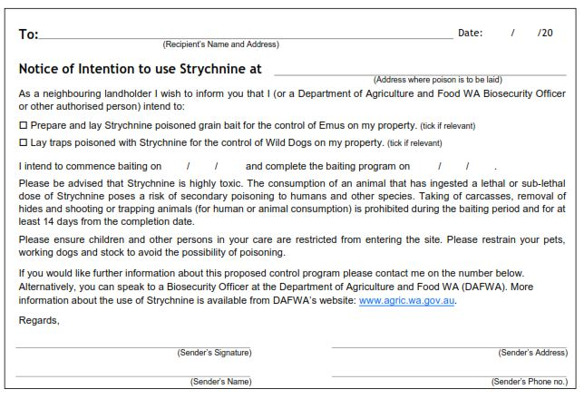



To: Click here to enter recipient’s name and address. Date: Click here to enter date.

Notice of Intention to use strychnine at Click here to enter Address where poison is to be laid.

As a neighbouring landholder I wish to inform you that I (or a Department of Agriculture and Food, WA biosecurity officer or other authorised people) intend to:

Prepare and lay strychnine poisoned grain bait for the control of emus on my property. (Tick if relevant)

Lay traps poisoned with strychnine for the control of wild dogs on my property. (Tick if relevant)

I intend to commence baiting on Click here to enter date and complete the baiting program on Click here to enter date.

Please be advised that strychnine is highly toxic. The consumption of an animal that has ingested a lethal or sub-lethal dose of strychnine poses a risk of secondary poisoning to humans and other species. Taking of carcasses, removal of hides and shooting or trapping animals (for human or animal consumption) is prohibited during the baiting period and for at least 14 days from the completion date.

Please ensure children and other persons in your care are restricted from entering the site. Please restrain your pets, working dogs and stock to avoid the possibility of poisoning.

If you would like further information about this proposed control program please contact me on the number below.

Alternatively, you can speak to a biosecurity officer at the Department of Agriculture and Food, Western Australia (DAFWA). More information about the use of strychnine is available from the [DAFWA website](http://www.agric.wa.gov.au).

Regards,



Sender’s name: Click here to enter sender’s name.

Sender’s address: Click here to enter address.

Sender’s phone number: Click here to enter phone number.